**MODULE: 1 (HTML)**

**• Are the HTML tags and elements the same thing?**

Ans.) No, the HTML tags and elements are not the same.

HTML tags are used to design a webpage and are used to mark the beginning and end of HTML elements.

While, HTML elements consist of an opening tag, content and a closing tag.

**• What are tags and attributes in HTML?**

Ans.) Tags are markers that define the beginning, and end on elements.

Attributes provides additional information about HTML elements and are always included in the opening tag.

**• What are void elements in HTML?**

Ans.) Void elements in HTML are those elements which do not have closing tag. E.g.- <br> tag, <hr> tag.

**• What are HTML Entities?**

Ans.) HTML entities are special codes used to represent reserve ed characters with special meaning in HTML. They start with an **ampersand(“&”)** and end with a **semicolon(“;”)**.

**• What are different types of lists in HTML?**

Ans.) There are mainly three type of lists in HTML.

They Are as follows:-

1. **Ordered List:-** It represents a list of items in a specific order. Each item is marked with a number or alphabet(small or capital) or roman numbers.
2. **Unordered List:-** It represents a list of items without any particular order. Each item is typically marked with a disk or circle or square.
3. **Definition/Description List:-** It represents a list of term-definition pairs. Each **term** is marked with **<dt> (definition term)** and each **definition** is marked with **<dd> (definition description)**.

**• What is the ‘class’ attribute in HTML?**

Ans.) –

**• What is the difference between the ‘id’ attribute and the ‘class’ attribute of HTML elements?**

Ans.) –

**• What are the various formatting tags in HTML?**

Ans.)

1. **Paragraph Tag[<p>]:-** Defines a paragraph of text.
2. **Heading Tag[<h1> to <h6>]:-** Defines headings of different levels, with <h1> being the highest and <h6> the lowest.
3. **Bold Tag[<bold> or <strong>]:**- Represents bold text.
4. **Italic Tag[<i> or <em> or <cite>]:-** Represents italic text.
5. **Underline[<u> or <ins>]:**- Represents underlined text.
6. **Strikethrough[<s> or <strike> or <del>]:-** Represents text that is no longer accurate or relevant.
7. **Line Break[<br>]:-** Forces a line break within text.
8. **Thematic Break[<hr>]:-** Represents a horizontal line rule.
9. **Subscript[<sub>]:-** Represents subscript text.
10. **Superscript[<sup>]:-** Represents superscript text.
11. **Center Tag[<center>]:-** Used to center align the text.
12. **Abbreviation[<abbr>]:-** Used to define an acronym or abbreviation.
13. **Blockquote[<blockquote>]:**- Used to make space on both sides of content.
14. **Marquee[<marquee**>]:- Used to make text scroll up, dpwn left or right.

**• How is Cell Padding different from Cell Spacing?**

Ans.) **Cell Padding** defines the space between cell content and cell border in a table. **Cell Spacing** defines the space between adjacent table cells.

**• How can we club two or more rows or columns into a single row or column in an HTML table?**

Ans.) We can club two or more rows by using the attribute **rowspan**. While, We can club two or more columns by using the attribute **colspan**.

**• What is the difference between a block-level element and an inline element?**

Ans.) **Block-Level Elements** start on a new line, and takes up the full width available. While, **Inline Elements** Do not start on a new line, and takes up only a smuch width necessary.

**• How to create a Hyperlink in HTML?**

Ans.) To create a hyperlink in HTML, use the **<a>(anchor) tag with the “href” attribute.** The code is as follows:

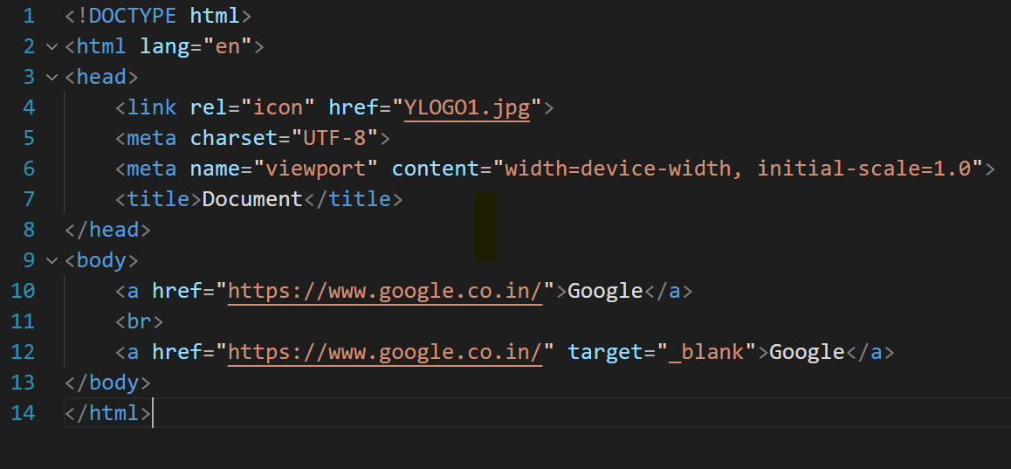

**• What is the use of an Iframe tag?**

Ans.) It is used to embed external content like another webpage, document or media within the current webpage.

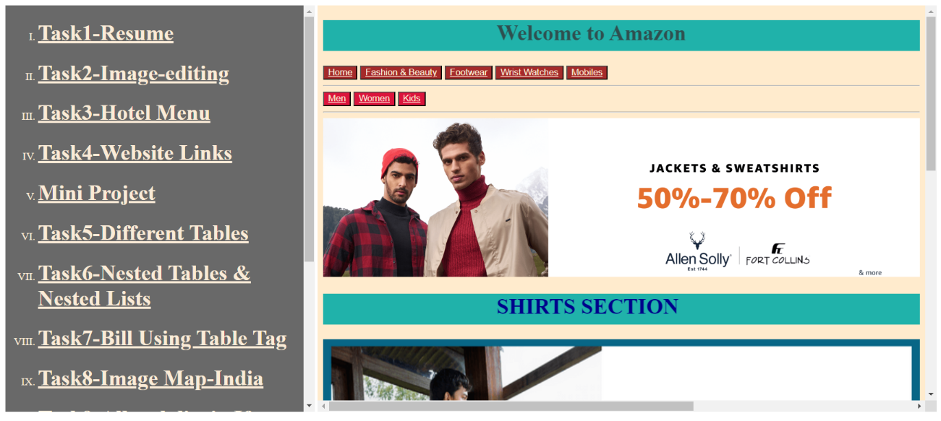

**• What is the use of a span tag? Explain with example?**

Ans.) –

**• How to insert a picture into a background image of a web page?**

Ans.) To insert background image, we can use the CSS property of **background image.**

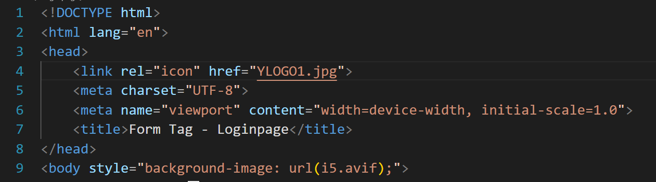

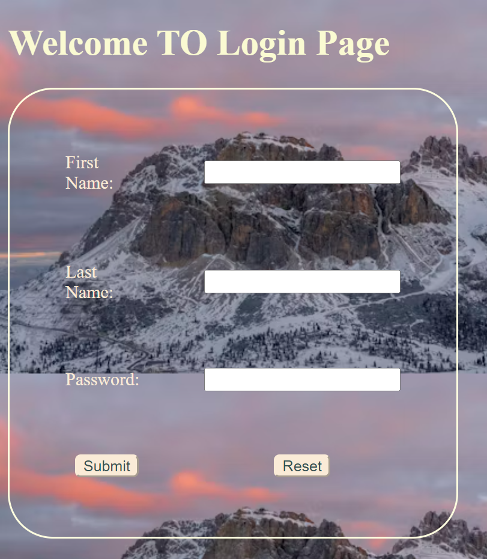

**• How are active links different from normal links?**

Ans.) Normal Links represent links in their default state. While, Active Links represent links that are currently being clicked or interacted with.

**• What are the different tags to separate sections of text?**

Ans.) Tags to separate sections of text are:-

1. **Paragraph tag[<p>]**
2. **Heading tag[<h1> to <h6>]**

**• What is SVG?**

Ans.) It is used to define graphics for the web, i.e., it is used to add different shapeslike square, rectangle, circle, etc. on a webpage.

Its full form is **Scalable Vector Graphics(SVG)**.

**• What is difference between HTML and XHTML?**

Ans.)

| **HTML** | **XHTML** |
| --- | --- |
| 1. HTML is an SGML-based language. That is, it defines the standard for generalizing the markup languages for documents. SGML stands for Standard Generalized Markup Language. | 1. XHTML is an XML-based language, which means it manipulates and processes data using XML technologies. |
| 2. HTML is not a case-sensitive language. | 2. XHTML is a case-sensitive language. |
| 3. HTML empty elements do not require a closing tag at the end, not even a "/" symbol to signify the end of the tag. | 3. XHTML empty elements must always be closed; that is, there must be a "/" symbol at the end of the empty element. |
| 5. The tags and attributes in HTML can be specified either in lowercase or uppercase since it is not case-sensitive. | 5. All XHTML elements and attributes must be in lowercase since it is a case-sensitive language. |
| 6. The HTML document requires a minimum of four tags to create an HTML page that is <html>, <head>, <title>, and <body>. The <!DOCTYPE> declaration is not necessary for HTML. | 6. An XHTML document must contain the <!DOCTYPE> declaration followed by the <html>, <head>, <title>, and <body> tags in its document to create a webpage. Moreover, the xmlns attribute in <html> tag is also necessary. |
| 7. Some HTML elements may function properly without a closing tag. | 7. All the XHTML elements must be closed. Even the empty elements also require a closing tag. |
| 8. Some elements in HTML may be improperly nested; that is, they do not need to be closed in the order in which they are opened. | 8. All XHTML elements, however, must be properly nested within each other; that is, they must be closed in the order in which they were opened. |
| 9. It is not mandatory to put quotes while using the attributes in HTML. | 9. It is mandatory to put quotes around an attribute in XHTML. |
| 10. It allows attribute minimization, where boolean attributes can omit their values. For example, "checked". | 10. It does not allow attribute minimization. All the attributes must be written in full attribute-value pairs. |
| 11. The webpage is displayed even if the HTML document has some errors in it. | 11. There is a more strict error handling in XHTML. |
| 12. It can have a filename extension of.html or.htm. | 12. Its filename extension can be .xhtml, .xht, or .xml. |